FACULTY EVALUATION
Programme Name: Social Entrepreneurship Development Program (SEDP)- Start Tanzania Module 3 (2nd February - 6th February 2026)
Session: Monitoring and social impact measures
Faculty Name: Janet Wanjiku
No. of Respondents: 15
No. of Participants: 15
Evaluation Parameter | (%) Individual Score | (%) Programme Average
Punctuality (Commencement and Completion of Sessions) | 95 | 95
How well do you understand the core concepts presented? | 88 | 87
Rate your confidence in applying the new skills learnt | 87 | 88
Degree of Faculty preparedness for the sessions | 92 | 91
Content and methodology of the program | 93 | 91
Quality of class and group discussions | 92 | 89
The information presented in the course is relevant to my work (ministry) | 91 | 91
Average scores | 91 | 90

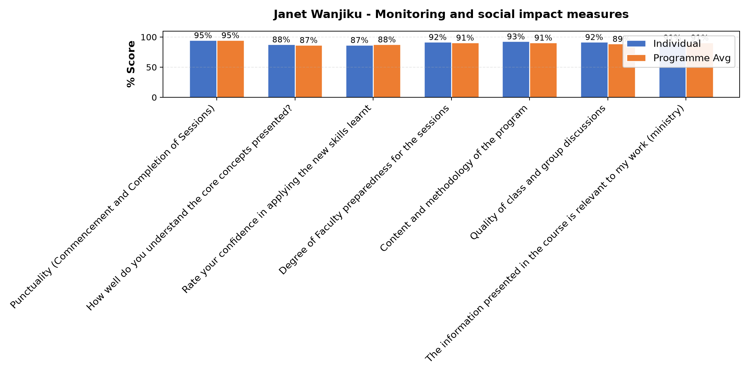

Comments & Feedback
- • Finance
- • Mambo yote yalienda sawa Nitajitahidi kutoa elimu kwa jamii iweze kupata maendeleo pia na mradi uweze kukua.
- • Net work and other on line things
- • She is a good Teacher
- • Lack of regular exercise
- • Good
- • The limited cooperation of my fellow community members
- • It was smart and well prepared
SUBMITTED THROUGH:
SBS Evaluation Automation System

